TITLE (TNR, 14, BOLD, CENTER, SINGLE SPACING, UPPERCASE)

Adam Hafiz¹
Amzar2
Hannah3
(TNR, 12, Bold, Centre, Single Spacing, Capitalize Each Word)

¹Faculty Economic, Universiti Utara Malaysia (UUM), Malaysia, (adam@uum.edu.my)
²Faculty Account, Universiti Utara Malaysia (UUM), Malaysia, (amzar@uum.edu.my)
³Faculty Finance, Universiti Teknologi Mara (UiTM), Malaysia, (hannah@uitm.edu.my)
(TNR, 10, Align Left, Capitalize Each Word)

Abstract/Creative Statement: (TNR, 12, italic, justify, single spacing) - The abstract/creative statement should not more than 300 words each. The abstract/creative statement should not only indicate the subject and scope of the paper, but also summarize the author’s conclusion. Structured abstract/creative statement must be a brief, comprehensive summary of the contents of the paper. It allows readers to survey the contents of a papers quickly.

Keywords: (TNR, 12, Italic, Justify, Single Spacing, Capitalize Each Word) - Min 3 Keywords and Max 7 Keywords

Introduction – Heading 1 (TNR, 12, Bold, Align Left, Capitalize Each Word)
Since the mid-20th century when Malaysia achieved its independence from the British, Malay popular music has evolved from one style to another……………...
(TNR, 12, single spacing, justify)

Background of Music – Heading 1 (TNR, 12, Bold, Align Left, Capitalize Each Word)
The Origins of Popular Music in Malaysia – Heading 2 (TNR, 12, Bold, Italic, Capitalize Each Word)
In the late 19th Century, Malay traditional Folk music, which is classified as music transmitted orally, as well music with unknown composers……………...
(TNR, 12, single spacing, justify)

The Cultural Influential Factors on Malay Popular Music – Heading 3 (TNR, 12, Bold, Italic, Tab Inside, Capitalize Each Word)
The goal of sustainable tourism is to reduce poverty, respect socio-cultural authenticity, and be responsible for the use of environmental resources, and not only encourage but also….…
(TNR, 12, single spacing, justify).

Table 1: Example (TNR, 12, Single Spacing, Bold, Centre, Capitalize Each Word)
Example | Example | Example
Example | Example | Example
Example | Example | Example
Source: (TNR,10, Single Spacing, Align Left, Capitalize Each Word)

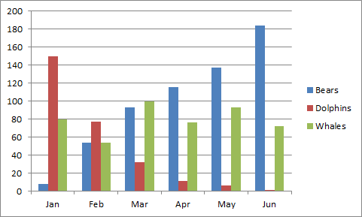
Figure 1: Example (TNR, 12, Single Spacing, Bold, Centre, Capitalize Each Word)
Source: (TNR,10, Single Spacing, Align Left, Capitalize Each Word)

References (APA Sixth Edition, Single Spacing)
Biography of Researcher-Artist/ Artist-Researcher 100–120 words

PLEASE SUBMIT YOUR FULL PAPER IN MICROSOFT WORD FORMAT

